

**Name – Atrayee Pathak**

**Batch – B1(NH)**

**Sap id – 500105632**

**Triggering Builds using two different Jenkins Agents(Slaves)**

1. Step1 is to Create 2 EC2 Instances with the same AMI Image i.e Ubuntu

2. Step 2 is to create a new key pair login if not created already And choose the key pair you created and click on launch

3. When Instances will be in the running state ssh into one of the machine

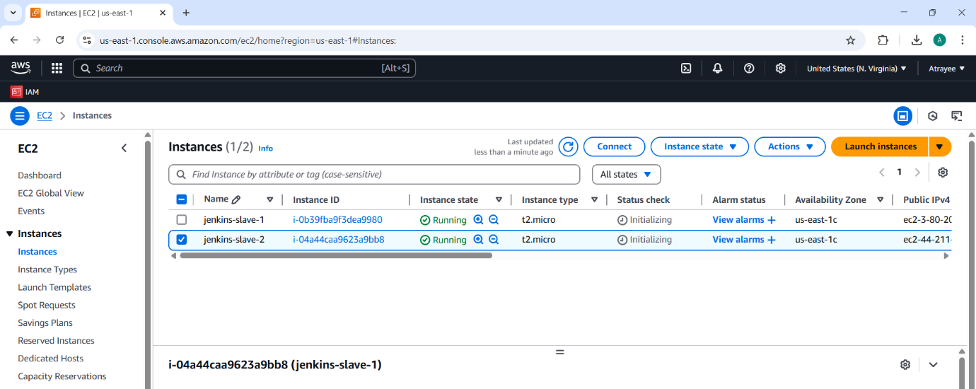

4. Connecting to jenkins-slave-1 using ssh Command to ssh is ~ssh -i ubuntu@

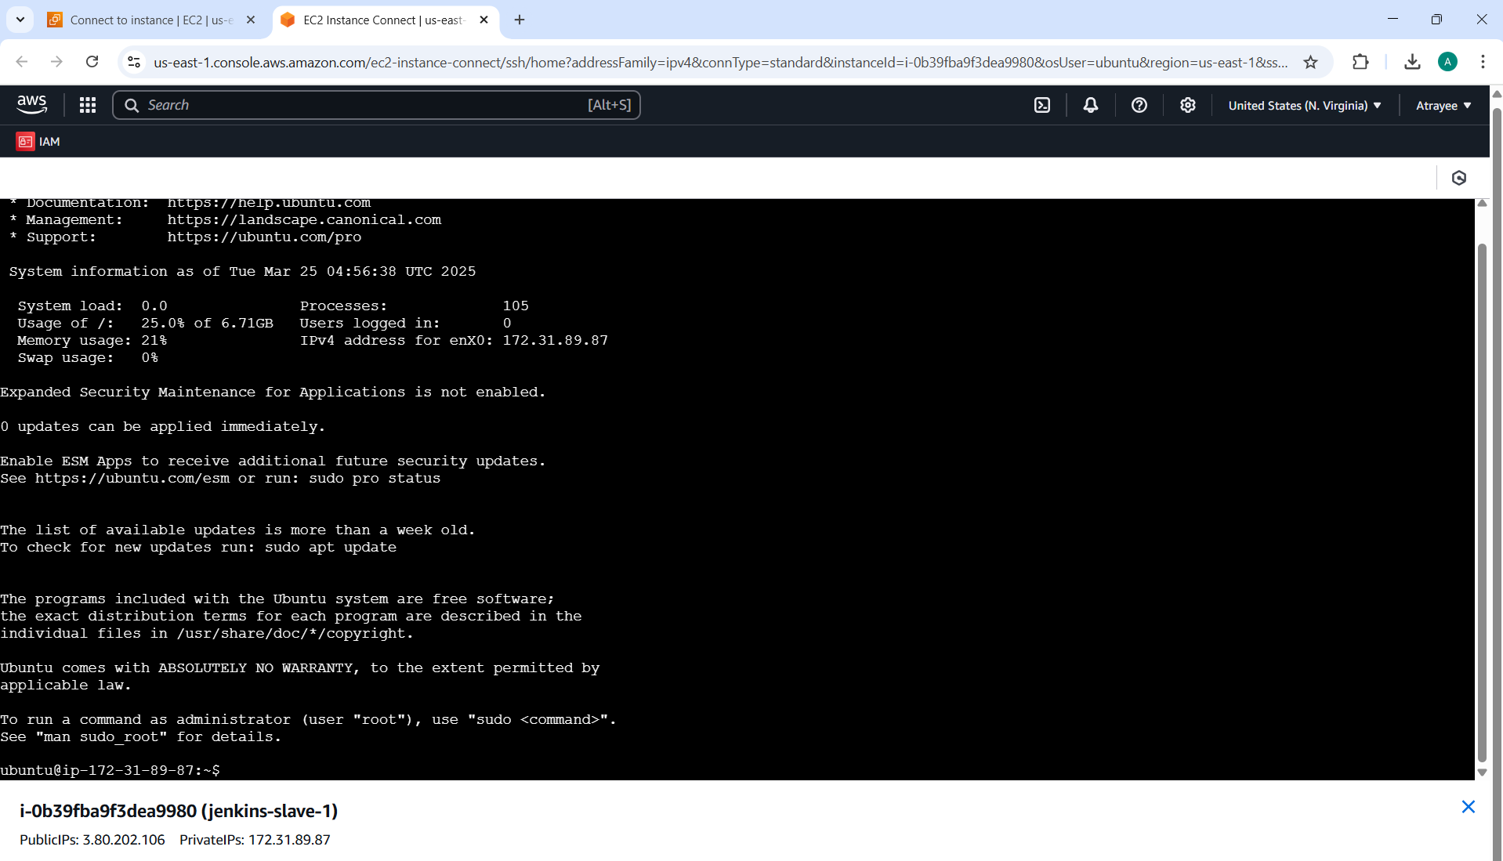

5. After getting access Download Java

Run the following cmds

~ sudo apt update -y

~ sudo apt install fontconfig openjdk-17-jre -y

After installation check for Java version

~ java –version



6. Now lets set up jenkins folder inside this ec2



7. Now lets create a ssh public and private key for this machine

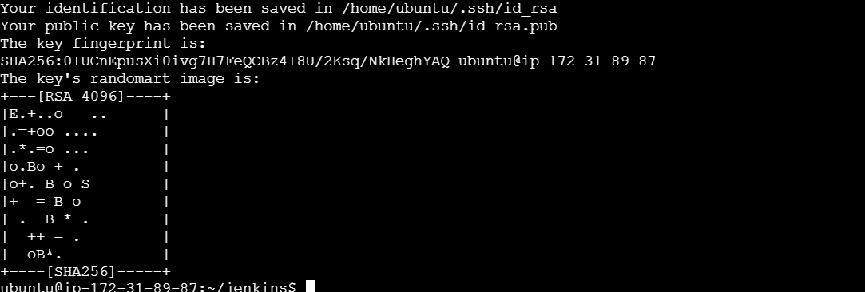

This will create a pair of public and private keys under .ssh/ folder



7: Add Nodes in Jenkins

Now, go to your **Jenkins Server UI**:

1. Open **Manage Jenkins** → **Manage Nodes and Clouds**
2. Click on **New Node** → Give it a name (**jenkins-slave-1**) → Choose **Permanent Agent**
3. In the **Remote Root Directory**, enter /home/ubuntu/jenkins/
4. **Launch method**: Select **Launch agents via SSH**
5. **Host**: Enter **Public IP** of the **jenkins-slave-1**
6. **Credentials**:
   * Click **Add** → **Jenkins**
   * Choose **SSH Username with private key**
   * **Username**: ubuntu
   * **Private Key**: Paste the **private key (id_rsa)** from ~/.ssh/id_rsa
7. Click **Save & Apply**

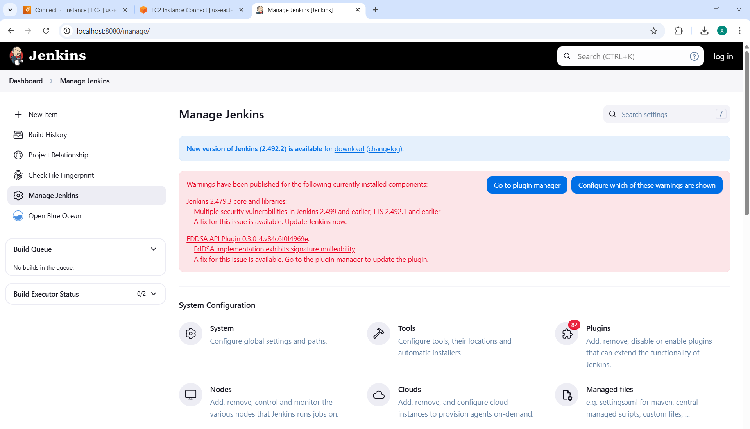

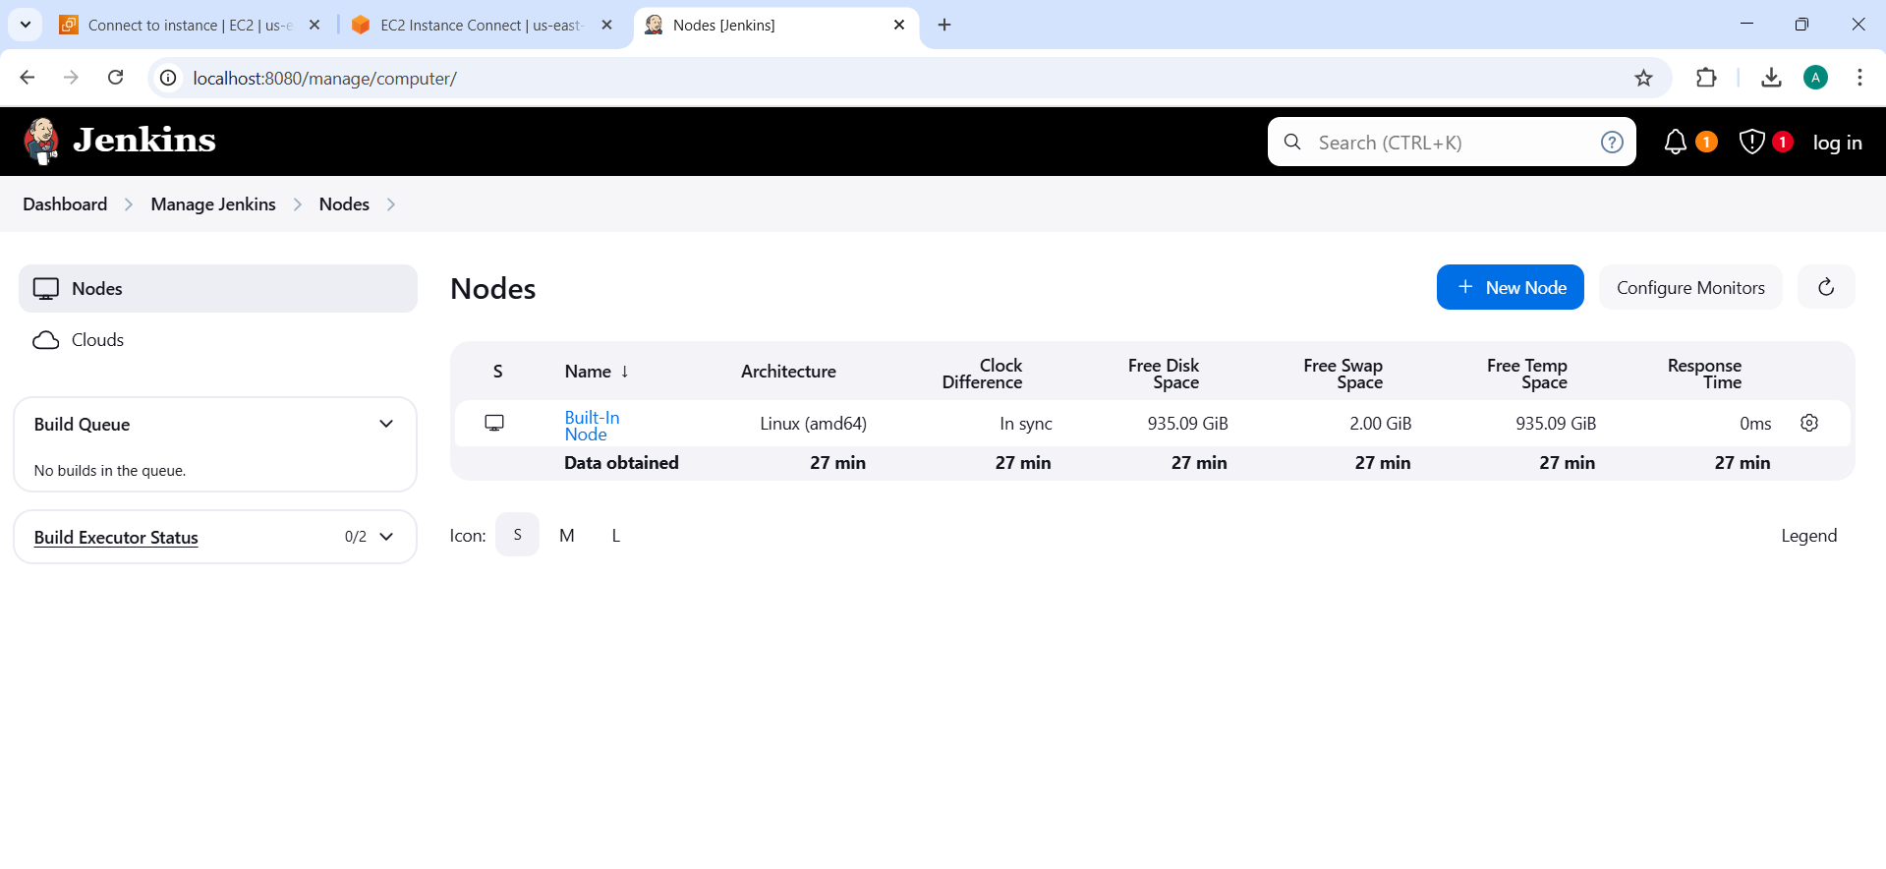

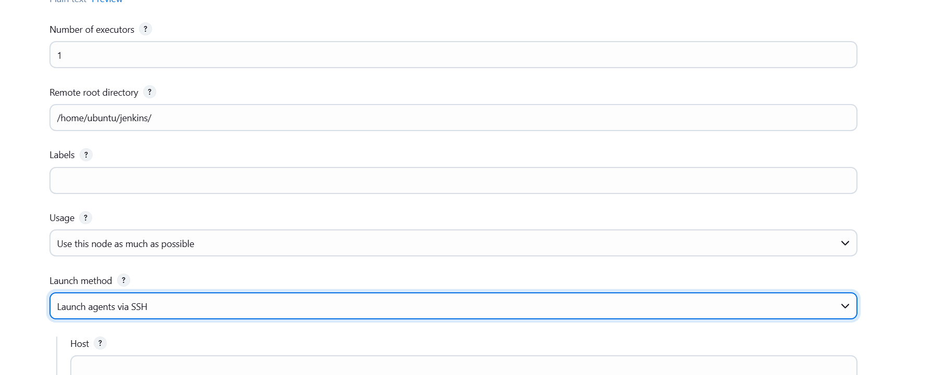

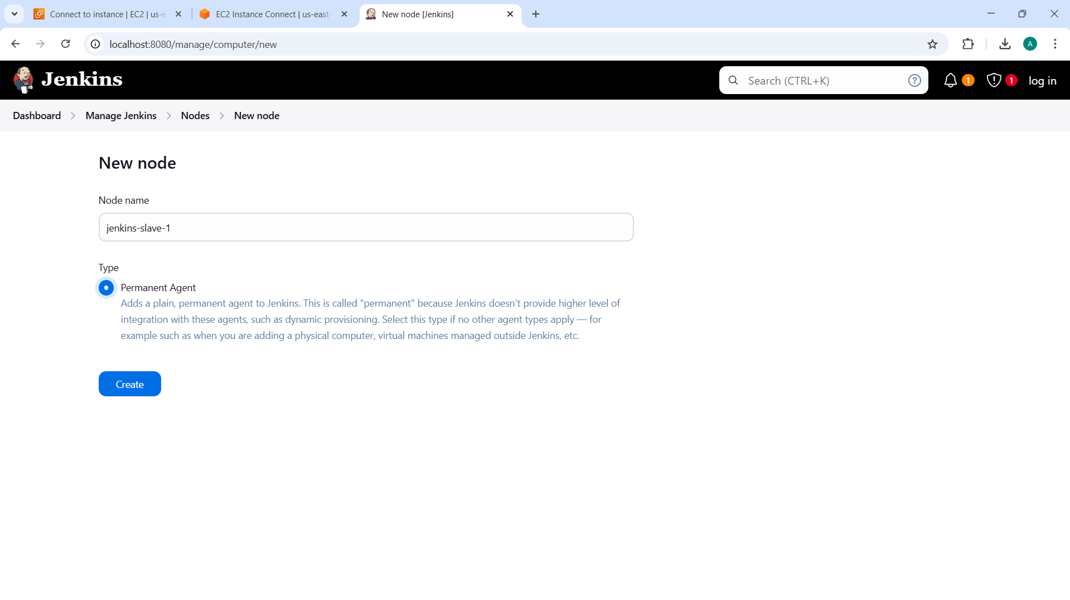

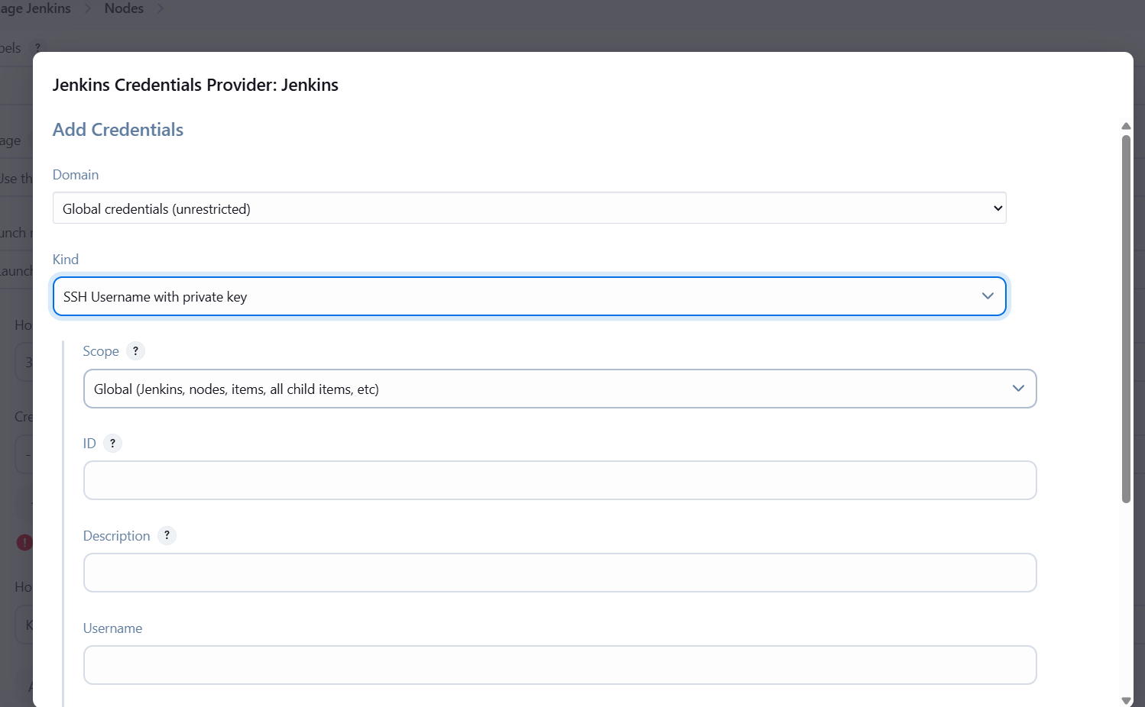

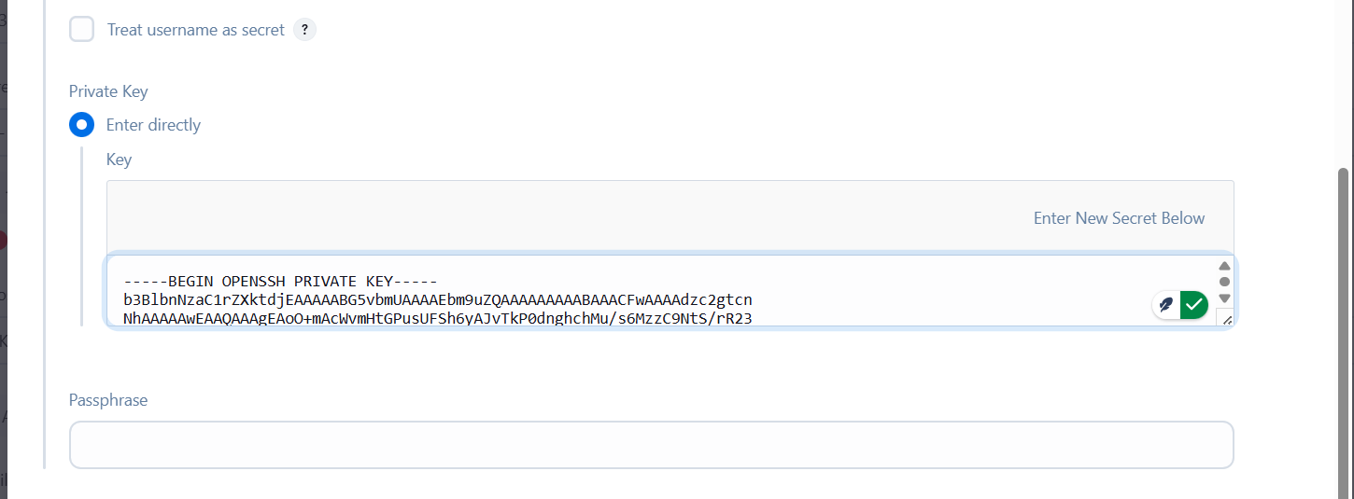

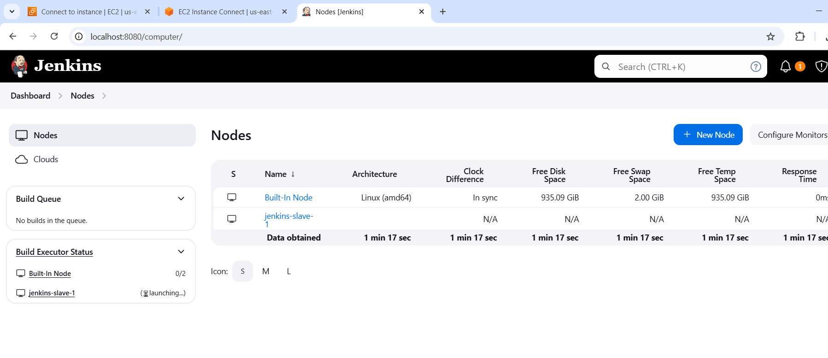

8. Check Build Logs

1. **Open Build History → Click on a completed build**
2. **Check the Console Output, which should confirm that the job ran on the respective slave.**